
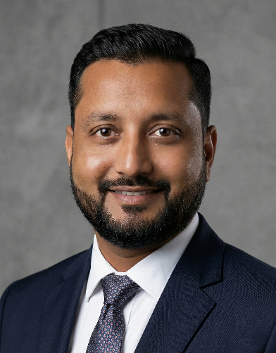
SAGAR PATEL
COMPUTER EDUCATOR & WEB DEVELOPER
^ B/H Primary School, At. Khaladi, Ta. Mahudha,
Dist. Kheda, Gujarat, India – 387335
v +91 94289 02507 | ] sagarp451@gmail.com
q Portfolio & Live Projects: sagarpatel-portfolio.netlify.app
i www.linkedin.com/in/sagar-patel-dev

PROFESSIONAL SUMMARY .
A dedicated tech professional and BCA candidate (2025) with a strong foundation in full-stack web development and programming. Backed by 13+ years of leadership and technical operations experience, I possess a unique blend of analytical problem-solving, team mentorship, and structured data management skills. Eager to leverage my technical expertise to build robust digital solutions as a Web Developer or to mentor the next generation of tech talent as a Computer Educator.
TECHNICAL SKILLS .
Web Development: HTML5, CSS3, JavaScript, PHP Programming: C, C++, Java
Databases & OS: MySQL, SQL, Windows, Linux Soft Skills: Leadership, Mentorship, Troubleshooting
ACADEMIC & WEB PROJECTS .

Blood Bank Donor Management System Tech Stack: PHP, MySQL, HTML/CSS
- Engineered a secure web platform to track blood inventory and manage donor profiles.
- Streamlined hospital requests with real-time database updates and secure authentication.
Online Car Rental System Tech Stack: PHP, MySQL, JavaScript
- Designed a dynamic vehicle booking system featuring inventory tracking.
- Implemented user authentication and dynamic pricing calculation logic.
Hospital Management System Tech Stack: PHP, MySQL, HTML
- Developed a full-stack application for storing and retrieving patient records.
- Focused on data security, seamless database connections, and an intuitive UI.
University & Employee Management Systems Tech Stack: Java, MySQL
- Created structured database systems to handle student and employee data efficiently.
- Integrated complex search, update, and reporting functionalities for internal operations.

1
PROFESSIONAL EXPERIENCE .

Senior Technical Operator & Supervisor June 2012 – July 2025 Drashti X-Ray Clinic, Nadiad
- Supervised daily technical operations, managing advanced imaging and computing equipment.
- Maintained complex, highly sensitive patient data records with 100% accuracy.
- Mentored and trained junior staff on operational protocols, software usage, and technical troubleshooting.
EDUCATION .
Bachelor of Computer Applications (BCA) 2025 Dr. Babasaheb Ambedkar Open University

Diploma in Radiology Technology 2011 Bharat Sevak Samaj
Bachelor of Commerce (B.Com) 2010 Gujarat University
PERSONAL INFORMATION .
Full Name: Sagarkumar Jitendrabhai Patel
Date of Birth: 12 July 1990
Marital Status: Married
Nationality: Indian
Address: B/H Primary School, At. Khaladi, Ta. Mahudha, Dist. Kheda, Gujarat, India – 387335
DECLARATION .
I hereby declare that all the information provided above is true and correct to the best of my knowledge and belief.

Sagar Patel

2

